**Provision an EKS cluster (AWS)**

* Terraform

AWS's Elastic Kubernetes Service (EKS) is a managed service that lets you deploy, manage, and scale containerized applications on Kubernetes.

In this tutorial, you will deploy an EKS cluster using Terraform. Then, you will configure kubectl using Terraform output and verify that your cluster is ready to use.

Warning

[AWS EKS clusters cost $0.10 per hour](https://aws.amazon.com/eks/pricing/), so you may incur charges by running this tutorial. The cost should be a few dollars at most, but be sure to delete your infrastructure promptly to avoid additional charges. We are not responsible for any charges you may incur.

**Why deploy with Terraform?**

While you could use the built-in AWS provisioning processes (UI, CLI, CloudFormation) for EKS clusters, Terraform provides you with several benefits:

* **Unified Workflow** - If you already use Terraform to deploy AWS infrastructure, you can use the same workflow to deploy both EKS clusters and applications into those clusters.
* **Full Lifecycle Management** - Terraform creates, updates, and deletes tracked resources without requiring you to inspect an API to identify those resources.
* **Graph of Relationships** - Terraform determines and observes dependencies between resources. For example, if an AWS Kubernetes cluster needs a specific VPC and subnet configurations, Terraform will not attempt to create the cluster if it fails to provision the VPC and subnet first.

**Prerequisites**

The tutorial assumes some basic familiarity with Kubernetes and kubectl but does not assume any pre-existing deployment.

You can complete this tutorial using the same workflow with either Terraform Community Edition or Terraform Cloud. Terraform Cloud is a platform that you can use to manage and execute your Terraform projects. It includes features like remote state and execution, structured plan output, workspace resource summaries, and more.

Select the **Terraform Community Edition** tab to complete this tutorial using Terraform Community Edition.

Terraform CloudTerraform Community Edition

This tutorial assumes that you are familiar with the Terraform workflow. If you are new to Terraform, complete the [Get Started collection](https://developer.hashicorp.com/terraform/tutorials/aws-get-started) first.

For this tutorial, you will need:

* Terraform v1.3+ installed locally.
* an [AWS account](https://portal.aws.amazon.com/billing/signup?nc2=h_ct&src=default&redirect_url=https%3A%2F%2Faws.amazon.com%2Fregistration-confirmation#/start)
* the AWS CLI v2.7.0/v1.24.0 or newer, [installed](https://docs.aws.amazon.com/cli/latest/userguide/getting-started-install.html) and [configured](https://docs.aws.amazon.com/cli/latest/userguide/cli-chap-configure.html)
* [AWS IAM Authenticator](https://docs.aws.amazon.com/eks/latest/userguide/install-aws-iam-authenticator.html)
* [kubectl](https://kubernetes.io/docs/tasks/tools/) v1.24.0 or newer

**Set up and initialize your Terraform workspace**

In your terminal, clone the example repository for this tutorial.

$ git clone https://github.com/hashicorp/learn-terraform-provision-eks-cluster

Change into the repository directory.

$ cd learn-terraform-provision-eks-cluster

This example repository contains configuration to provision a VPC, security groups, and an EKS cluster with the following architecture:

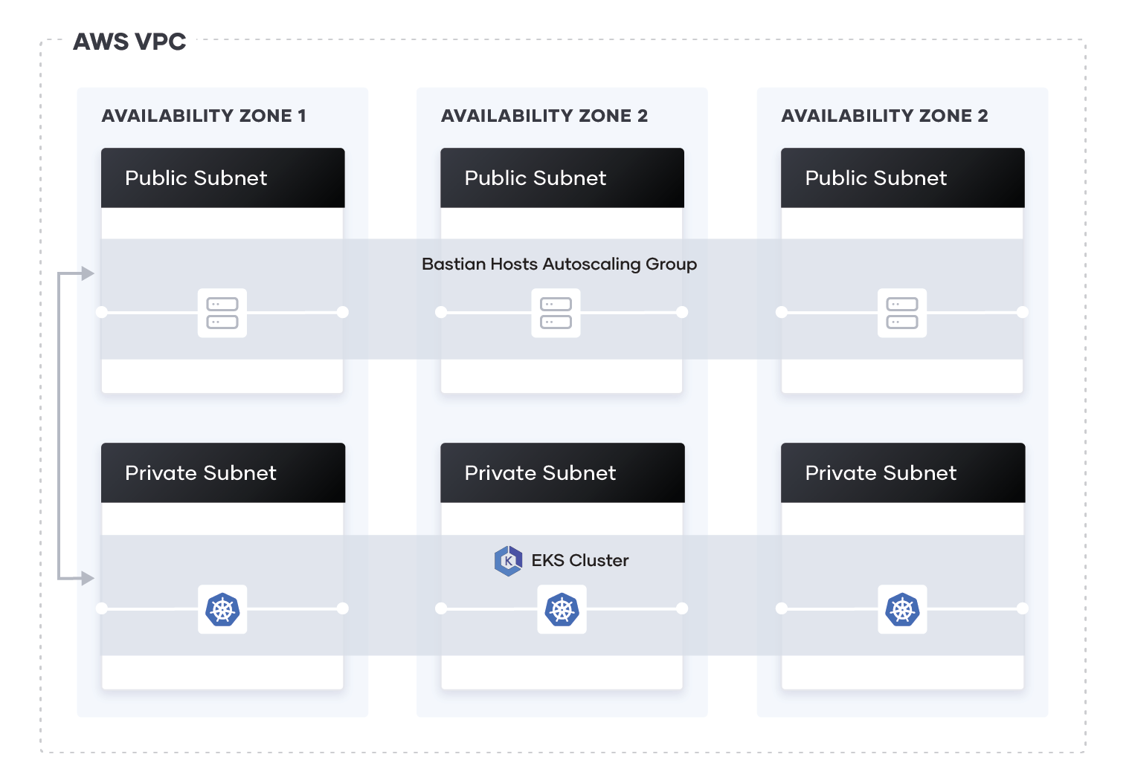

The configuration defines a new VPC in which to provision the cluster, and uses the public EKS module to create the required resources, including Auto Scaling Groups, security groups, and IAM Roles and Policies.

Open the main.tf file to review the module configuration. The eks_managed_node_groups parameter configures the cluster with three nodes across two node groups.

main.tf

eks_managed_node_groups = {

one = {

name = "node-group-1"

instance_types = ["t3.small"]

min_size = 1

max_size = 3

desired_size = 2

}

two = {

name = "node-group-2"

instance_types = ["t3.small"]

min_size = 1

max_size = 2

desired_size = 1

}

}

**Initialize configuration**

Terraform CloudTerraform Community Edition

Open your terraform.tf file and comment out the cloud block that configures the Terraform Cloud integration.

terraform.tf

terraform {

/*

cloud {

workspaces {

name = "learn-terraform-eks"

}

}

*/

required_providers {

aws = {

source = "hashicorp/aws"

version = "~> 5.7.0"

}

}

required_version = ">= 1.3"

##...

}

Initialize this configuration.

$ terraform init

Initializing the backend...

##...

Terraform has been successfully initialized!

You may now begin working with Terraform. Try running "terraform plan" to see

any changes that are required for your infrastructure. All Terraform commands

should now work.

If you ever set or change modules or backend configuration for Terraform,

rerun this command to reinitialize your working directory. If you forget, other

commands will detect it and remind you to do so if necessary.

**Provision the EKS cluster**

Run terraform apply to create your cluster and other necessary resources. Confirm the operation with a yes.

This process can take up to 10 minutes. Upon completion, Terraform will print your configuration's outputs.

$ terraform apply

## ...

Terraform used the selected providers to generate the following execution plan. Resource actions are indicated with the following symbols:

+ create

<= read (data resources)

Terraform will perform the following actions:

## ...

Plan: 63 to add, 0 to change, 0 to destroy.

Changes to Outputs:

+ cluster_endpoint = (known after apply)

+ cluster_name = (known after apply)

+ cluster_security_group_id = (known after apply)

+ region = "us-east-2"

Do you want to perform these actions in workspace "learn-terraform-eks"?

Terraform will perform the actions described above.

Only 'yes' will be accepted to approve.

Enter a value: yes

## ...

Apply complete! Resources: 63 added, 0 changed, 0 destroyed.

Outputs:

cluster_endpoint = "https://128CA2A0D737317D36E31D0D3A0C366B.gr7.us-east-2.eks.amazonaws.com"

cluster_name = "education-eks-IKQYD53K"

cluster_security_group_id = "sg-0f836e078948afb70"

region = "us-east-2"

**Configure kubectl**

After provisioning your cluster, you need to configure kubectl to interact with it.

First, open the outputs.tf file to review the output values. You will use the region and cluster_name outputs to configure kubectl.

outputs.tf

output "cluster_endpoint" {

description = "Endpoint for EKS control plane"

value = module.eks.cluster_endpoint

}

output "cluster_security_group_id" {

description = "Security group ids attached to the cluster control plane"

value = module.eks.cluster_security_group_id

}

output "region" {

description = "AWS region"

value = var.region

}

output "cluster_name" {

description = "Kubernetes Cluster Name"

value = module.eks.cluster_name

}

Run the following command to retrieve the access credentials for your cluster and configure kubectl.

$ aws eks --region $(terraform output -raw region) update-kubeconfig \

--name $(terraform output -raw cluster_name)

You can now use kubectl to manage your cluster and deploy Kubernetes configurations to it.

**Verify the Cluster**

Use kubectl commands to verify your cluster configuration.

First, get information about the cluster.

$ kubectl cluster-info

Kubernetes control plane is running at https://128CA2A0D737317D36E31D0D3A0C366B.gr7.us-east-2.eks.amazonaws.com

CoreDNS is running at https://128CA2A0D737317D36E31D0D3A0C366B.gr7.us-east-2.eks.amazonaws.com/api/v1/namespaces/kube-system/services/kube-dns:dns/proxy

To further debug and diagnose cluster problems, use 'kubectl cluster-info dump'.

Notice that the Kubernetes control plane location matches the cluster_endpoint value from the terraform apply output above.

Now verify that all three worker nodes are part of the cluster.

$ kubectl get nodes

NAME STATUS ROLES AGE VERSION

ip-10-0-1-50.us-east-2.compute.internal Ready <none> 6m20s v1.24.7-eks-fb459a0

ip-10-0-3-158.us-east-2.compute.internal Ready <none> 6m41s v1.24.7-eks-fb459a0

ip-10-0-3-46.us-east-2.compute.internal Ready <none> 6m14s v1.24.7-eks-fb459a0

You have verified that you can connect to your cluster using kubectl and that all three worker nodes are healthy. Your cluster is ready to use.

**Clean up your workspace**

You have now provisioned an EKS cluster, configured kubectl, and verified that your cluster is ready to use.

To learn how to manage your EKS cluster using the Terraform Kubernetes Provider, leave your cluster running and continue to the [Kubernetes provider tutorial](https://developer.hashicorp.com/terraform/tutorials/kubernetes/kubernetes-provider).

Note

This tutorial's example configuration contains **only** the configuration to create an EKS cluster. You can also use Terraform to manage the Kubernetes objects deployed to a cluster, such as Deployments and Services. We recommend that you keep the Terraform configuration for each of those concerns separate, since their workflows and owners often differ.

Destroy the resources you created in this tutorial to avoid incurring extra charges. Respond yes to the prompt to confirm the operation.

$ terraform destroy

## ...

Plan: 0 to add, 0 to change, 63 to destroy.

Changes to Outputs:

- cluster_endpoint = "https://128CA2A0D737317D36E31D0D3A0C366B.gr7.us-east-2.eks.amazonaws.com" -> null

- cluster_name = "education-eks-IKQYD53K" -> null

- cluster_security_group_id = "sg-0f836e078948afb70" -> null

- region = "us-east-2" -> null

Do you really want to destroy all resources?

Terraform will destroy all your managed infrastructure, as shown above.

There is no undo. Only 'yes' will be accepted to confirm.

Enter a value: yes

## ...

Destroy complete! Resources: 63 destroyed.

If you used Terraform Cloud for this tutorial, after destroying your resources, delete the learn-terraform-eks workspace from your Terraform Cloud organization.

**Next steps**

For more information on the EKS module, visit the [EKS module](https://registry.terraform.io/modules/terraform-aws-modules/eks/aws/latest) page in the Terraform Registry.

To learn how to manage Kubernetes resources, your EKS cluster, or existing Kubernetes clusters, visit the [Kubernetes provider tutorial](https://developer.hashicorp.com/terraform/tutorials/kubernetes/kubernetes-provider).

You can also [use the Kubernetes provider to deploy custom resources](https://developer.hashicorp.com/terraform/tutorials/kubernetes/kubernetes-crd-faas).

For a more in-depth Kubernetes example, see [Deploy Consul and Vault on a Kubernetes Cluster using Run Triggers](https://developer.hashicorp.com/terraform/tutorials/kubernetes/kubernetes-consul-vault-pipeline) (this tutorial is GKE based).